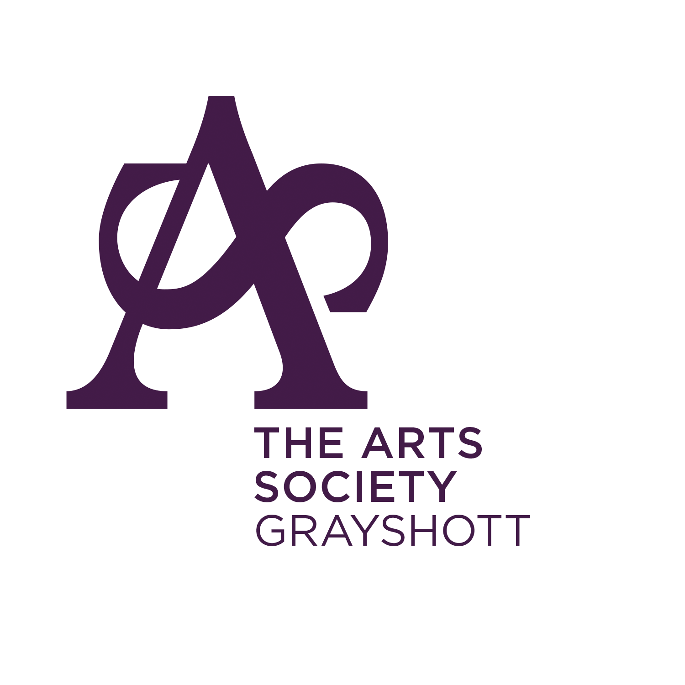
The Arts Society Grayshott

Please reply to the Membership Secretary
Mr. Geoff Douglas-Hiley
Flat 6, St Peters Court
Hylton Road
Petersfield
Hants. GU32 3JH
Telephone: 01730 601431

Dear Member,
MEMBERSHIP REQUEST – For New Members joining after 1st July

To join The Arts Society Grayshott please complete this form and, if appropriate, the attached Gift Aid form. For administrative purposes, each individual member needs to fill in a separate form. The subscription, payable now is £20.00 per member for membership for the remainder of the year. [The full-year subscription will be payable when membership is renewed in January]. Cheques should be made payable to The Arts Society Grayshott. Your Programme, Newsletter & Membership Card will be available once your subscription has been paid.

Please enter the information as requested below and return this form with your payment.

Title: Mr. /Mrs. /Ms. /Miss /Other: ……………………

Forename:.…………………………………………………. Surname: ……………………………………………………………………………
Address:…………………………………………………………………………………………………………………………………………………….
…………………………………………………………………………………………………………………………………………………………………
…………………………………………………………………………………………………………………………………………………………………
Post Code:…………………………………… Telephone number:…………………………………………………
Email address:…………………………………………………………………………………………………………………………………………..
Date:…………………………………………………………………
EMERGENCY CONTACT DETAILS (in case of illness or injury)

Name:………………………………………….. Relationship:……………………………….Phone No:…………………………………….

PLEASE PRINT DETAILS

GIFT AID DECLARATION
If you wish, the part of your annual subscription that is passed to the The Arts Society national body as an affiliation fee may be treated as a gift aid donation and they benefit there from. Any member so wishing should complete the Gift Aid Declaration overleaf. The Arts Society Grayshott also benefits to the amount of £1.00 for each member so signing.


Page 1 of 2

GIFT AID DECLARATION

The National Association of Decorative and Fine Arts Societies trading as The Arts Society
(Registered Charity No. 1089743)

Details of Donor

Title:…………………Forename: ……………………………………Surname:……………………………………………………………………..
Address:…………………………………………………………………………………………………………………………………………………………
……………………………………………………………………………………………………………..……………………………………………………………………………………………………………………………………………………………………………………………………………………………..
Post code:……………………………………………..

I wish the Charity mentioned above to treat all donations I make from the date of this declaration until I notify you otherwise as Gift Aid Donations. The amount of my donation is that part of my total annual subscription attributed to The Arts Society affiliation fee.

Date: ………………………………………………… Signature: ......................................................

_______________________________________________________________________________________

NOTES:
1. The HM Revenue & Customs accepts that a cheque drawn on a joint account to pay the subscription of a member is considered to be a payment from the member, even if the cheque is signed by the joint account holder who is not a member or who has not completed a Gift Aid Declaration.
2. The donor must pay an amount of Income Tax and/or Capital Gains Tax at least equal to the tax that the Charity reclaims on the member’s donation (currently 25p for each £1 given).
3. You can cancel this Declaration at any time by notifying the Membership Secretary in writing.
4. If in future your circumstances change and you no longer pay tax on your income and Capital Gains equal to the tax that the Charity reclaims you can cancel your Declaration (see note 3).
5. If you pay tax at a higher rate you can claim further tax relief in your self-assessment tax return.

DATA PROTECTION
To facilitate mailing the names, addresses, telephone numbers and e-mail addresses of all members of the Society are held on a computer. Your details will be processed fairly and lawfully and in accordance with the Society’s legitimate activities and your details will be disclosed only to The Arts Society and to other Member Societies, Area or organisations affiliated to The Arts Society or the Society. The information is restricted to that shown on the address label and will not be used for any other purpose. Telephone numbers and e-mail addresses of members may be used by The Arts Society to contact you. If you object to these conditions will you please advise the Membership Secretary in writing.

